Role - Business Analyst

The BA translated the requirements and needs of the customer into a business model: process models and business goals and business vision. The BA researches the market to understand customer requirements and collaborates with the Architect(s) to translate them into a technological vision. They are responsible for designing features etc. which will distinguish their project from the competition and often work closely with the Marketing and Sales teams. In our simulation, the BA will also be responsible for the User-interface design to facilitate easier user-interaction. The BA will work with the testers to come up with the user acceptance criteria written on the back of each user story.

Revision History

|  |  |  |
| --- | --- | --- |
| Week Number | Author | Description of changes |
| 2 | Michael Tran, John Chan | * Added risks/mitigation * Added business goals * Added user stories * Added UI Mock-ups * Added Business Process Models |
| 3 | Michael Tran, John Chan | * Added Variations in the domain * Refined wireframes using Axure |
|  |  |  |
|  |  |  |

1. Define Business Goals, Key Performance Indicators that measure the degree to which the goals have been achieved.

1. Meet deadlines
2. Ensure Customer Satisfaction / Implement user stories as wanted by customer (scores/grades)
3. Provide a simple and intuitive way for people to manage their bank accounts (feedback)

2. Define User Stories for the project.

|  |  |  |  |
| --- | --- | --- | --- |
| Name | Description | Estimation | Priority |
| **Securely Log in** | User should be able to securely log in as a bank employee or account holder | 2 days | 10 |
| **Securely Log out** | User should be able to log out and return to the log in screen | 1 day | 20 |
| **Sign up** | New customers should be able to open their first bank/user account with name, address, date of birth, email and account type. | 1 day | 10 |
| **Account Lookup** | Teller should be able to look up a customer’’s account to perform transactions for them. | 1 day | 20 |
| **Open Account** | Account holder/teller should be able to add a new bank account. | 1 day | 20 |
| **Forgot Password** | User should be able to retrieve password by submitting their email and account number | 2 days | 30 |
| **Display Accounts/Balances** | Account holder should be able to see all of their accounts | 1 day | 20 |
| **Close Account** | Account holder/teller should be able to disable and delete one of the customer’s bank accounts. | 2 days | 30 |
| **Close Account Failure** | Notify user that account must have zero balance to be closed. | 1 day | 30 |
| **Debit Account** | Account holder/teller should be able to withdraw money from a customer’s bank account IF withdrawal amount does not exceed the account balance. | 2 days | 20 |
| **Email Check** | Check is emailed to account holder once they debit their account. | 2 days | 20 |
| **Withdrawal/Transfer Failure** | Notify user that they can’t perform this action due to insufficient funds in source account | 1 day | 30 |
| **Credit Account** | Account holder/teller should be able to deposit money into one of customer’s bank account. Account holder can do this through credit and check. Teller can do this through cash as well. | 2 days | 20 |
| **Picture Check** | Account holder should be able to take a picture of a check to credit their account. | 1 day | 40 |
| **Transfer** | Account holder/Teller should be able to transfer money from one of the customer's bank accounts to another one of the same customer's account. | 2 days | 20 |
| **Wire** | Account holder/Teller should be able to transfer money from one of the customer's accounts to another customer's account. | 1 day | 20 |
| **Transfer Confirmation** | User must confirm this transaction | 1 day | 30 |
| **Calculate Interest** | Account holder should be able to view interests of each of their bank accounts. | 2 days | 15 |
| **Get Balance** | Balances of accounts should be listed to Account holder/Teller. | 1 day | 20 |
| **Transaction History** | Account holder/Teller should be able to view customer's transaction history | 1 day | 30 |
| **Print Statement** | Account holder should be able to retrieve and print out their transaction history | 2 days | 30 |

3. Business Process Models

Use blueworks live to document the business processes. Describe the flow of the main business processes within the scope of your project.

Business Processes - an account holder may close an account, view their transaction history, debit an account, credit an account, open a new account, and transfer or wire money from one account to another. A teller may do all of these things for a customer by accessing the customer's account using the account lookup tool. New customers can only sign up for an account.

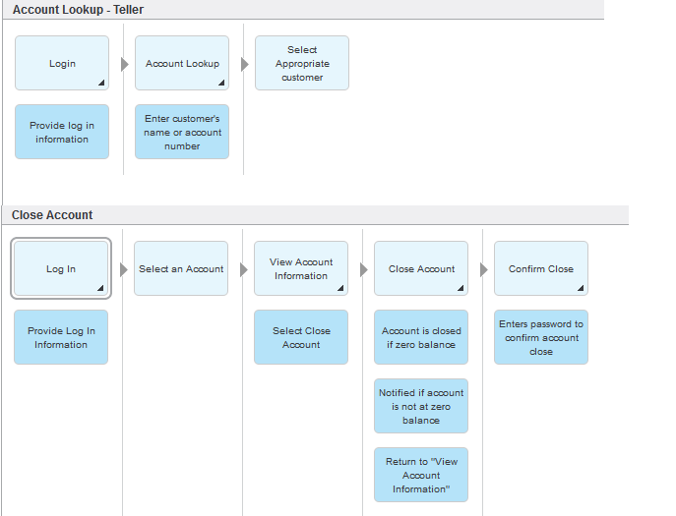

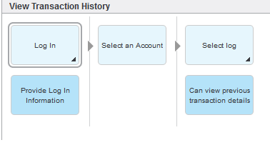

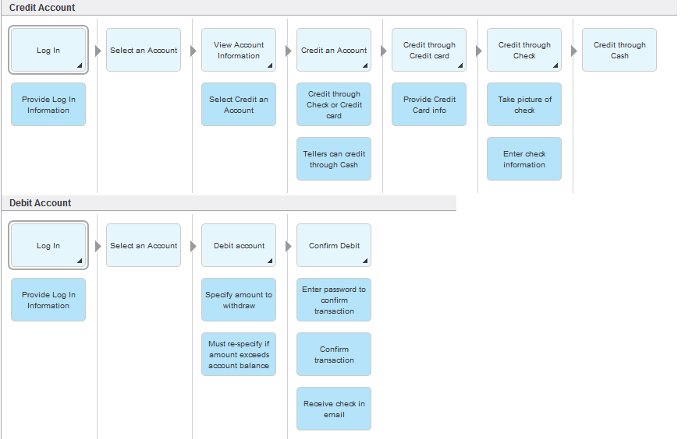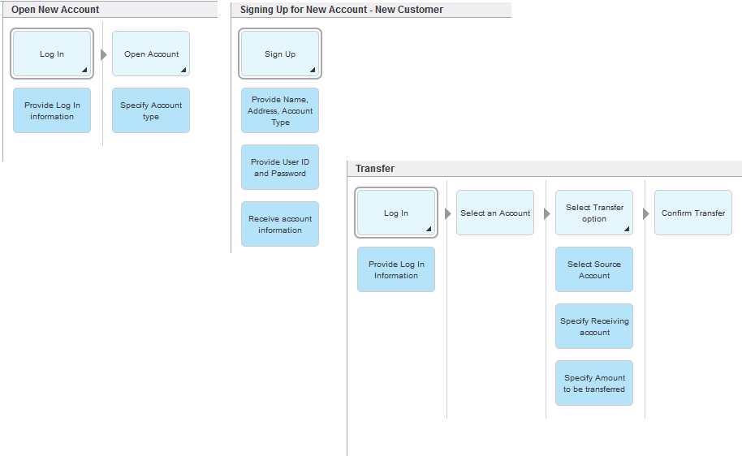

4. Wireframes: Simple UI mock-ups and flow between them.

UI flow for Account Holder:

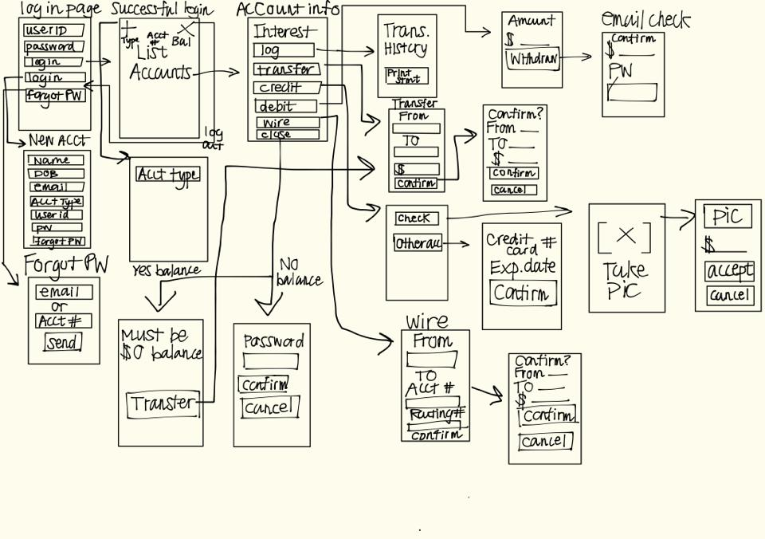

UI Flow for Bank Teller (Difference from Account Holder in green)

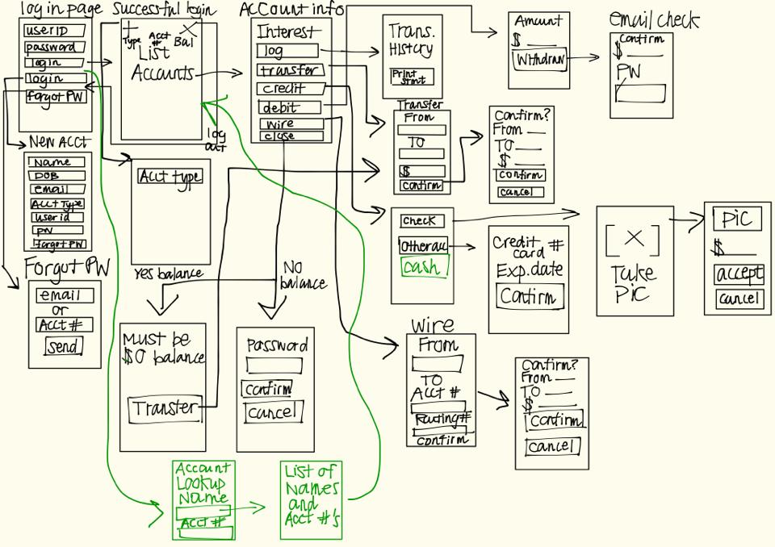

5.. Project Risks and Mitigation plan

|  |  |
| --- | --- |
| Risk | Counterplan |
| Calling in sick | Make sure everyone gets enough sleep |
| Midterms/Other classes/Out of town/Predictable conflicts | Let Project Manager know of any upcoming difficulties one may have |
| Unfamiliar with new technologies | Everyone should try to catch themselves up and get help from those who are experienced. |
| Holidays | Take them into account when planning ahead |

1. Variations in the Requirements

* As of now, there are two types of accounts: teller and customer

1. Tellers can access any customer’s accounts in order to perform bank functions for them
2. Customers can only access their own accounts and perform transactions with their own accounts.

* Different rules in interest rates based on account type

1. Checking Account Interest Rates
2. Savings Account Interest Rates

i. As of now, these are the only differences between Checking and Savings

* Different rules in interest rates based on Account balance over 30 days

1. Balance = $3000+ = 3% interest rate
2. Balance = $2000-3000 = 2% interest rate
3. Balance = $1000-2000 = 1% interest rate

* As of now, there are no rules on the number of accounts per customer, but may change.
* Different account types available to customer

1. Checking
2. Savings

Refined Wireframe (Does not include all of it):

* 1. Home
     1. User Interface

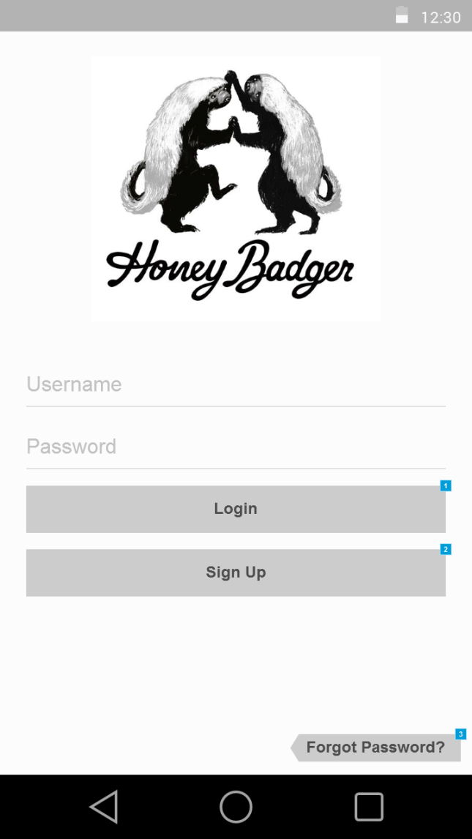

* + 1. Widget Table

|  |  |
| --- | --- |
| Footnote | Interactions |
| 1 | OnClick:  Case 1:  Open Successful Login in Current Window |
| 2 | OnClick:  Case 1:  Open Sign Up Page in Current Window |
| 3 | OnClick:  Case 1:  Open Sign Up Page in Current Window |

* 1. Successful Login
     1. User Interface

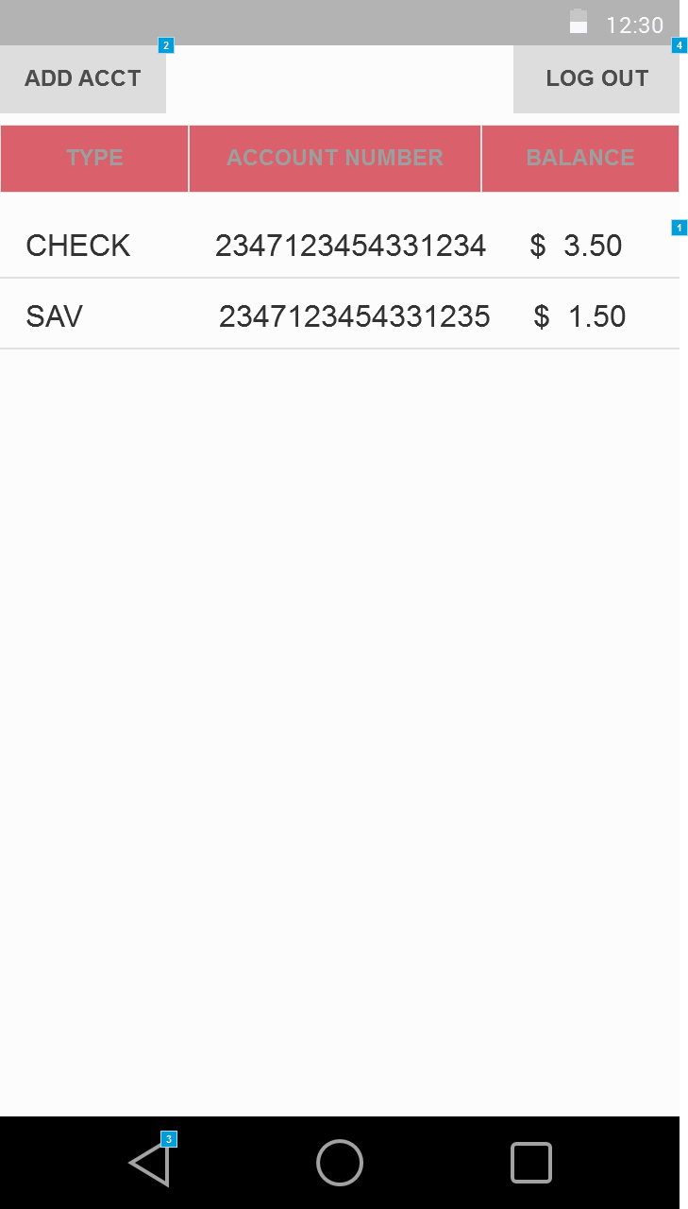

* + 1. Widget Table

|  |  |
| --- | --- |
| Footnote | Interactions |
| 1 | OnClick:  Case 1:  Open Account Info in Current Window |
| 2 | OnClick:  Case 1:  Open Add Account in Current Window |
| 3 | OnClick:  Case 1:  Open Home in Current Window |
| 4 | OnClick:  Case 1:  Open Home in Current Window |

* 1. Sign Up Page
     1. User Interface

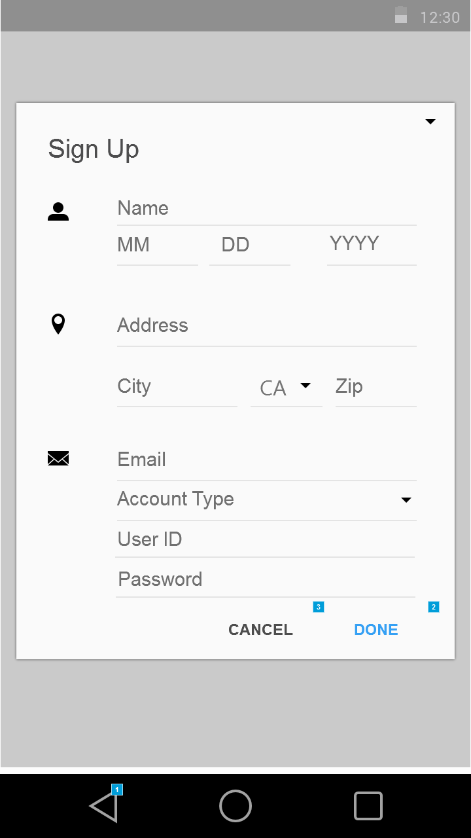

* + 1. Widget Table

|  |  |
| --- | --- |
| Footnote | Interactions |
| 1 | OnClick:  Case 1:  Open Home in Current Window |
| 2 | OnClick:  Case 1:  Open Home in Current Window |
| 3 | OnClick:  Case 1:  Open Home in Current Window |

* 1. Account Info
     1. User Interface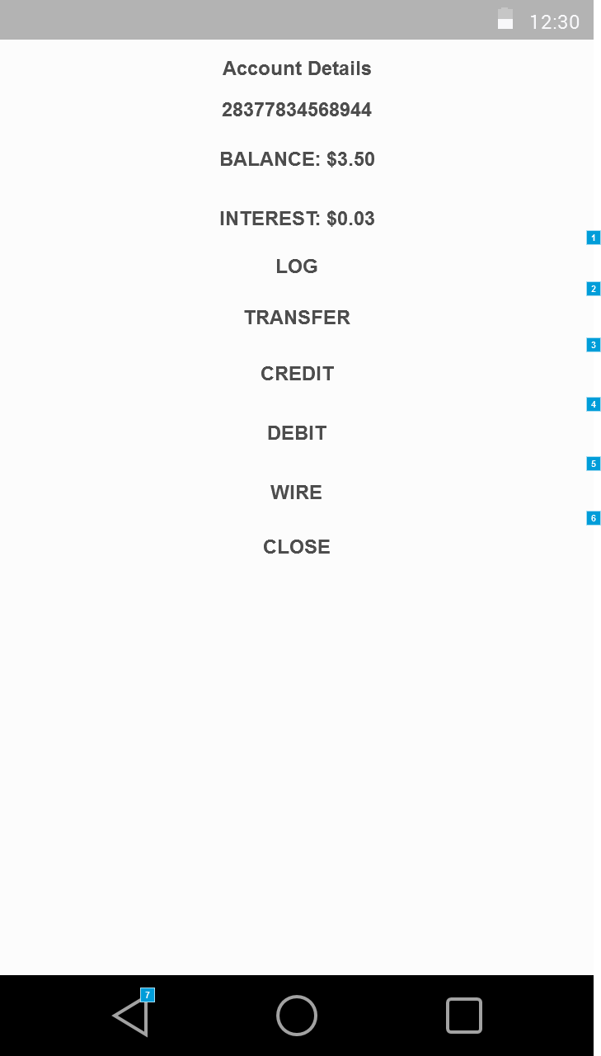
     2. Widget Table

|  |  |
| --- | --- |
| Footnote | Interactions |
| 1 | OnClick:  Case 1:  Open Log in Current Window |
| 2 | OnClick:  Case 1:  Open Transfer in Current Window |
| 3 | OnClick:  Case 1:  Open Credit in Current Window |
| 4 | OnClick:  Case 1:  Open Debit in Current Window |
| 5 | OnClick:  Case 1:  Open Wire in Current Window |
| 6 | OnClick:  Case 1:  Open Close - No Balance in Current Window |
| 7 | OnClick:  Case 1:  Open Successful Login in Current Window |

* 1. Transfer
     1. User Interface

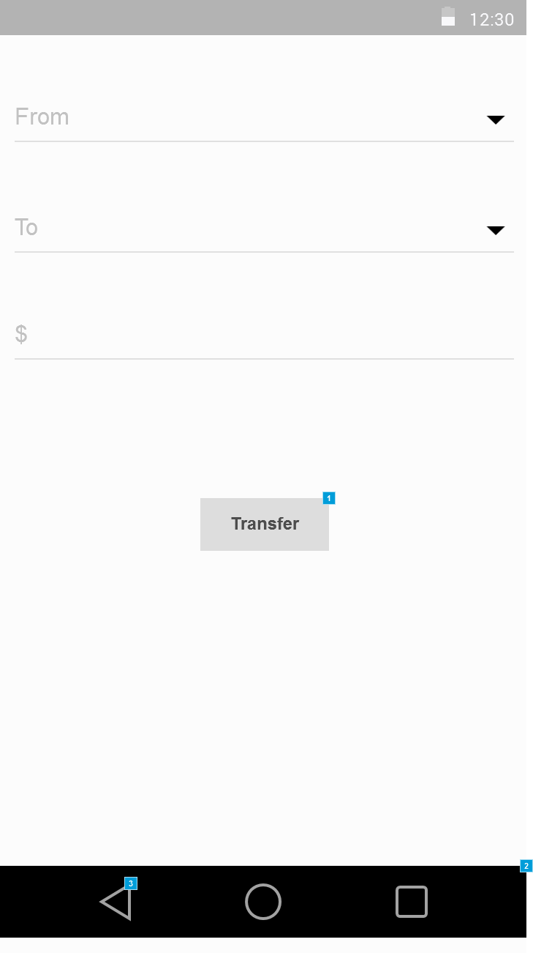

* + 1. Widget Table

|  |  |
| --- | --- |
| Footnote | Interactions |
| 1 | OnClick:  Case 1:  Open Transfer Confirmation in Current Window |
| 2 | OnClick:  Case 1: |
| 3 | OnClick:  Case 1:  Open Account Info in Current Window |

Transfer Confirmation

* + 1. User Interface

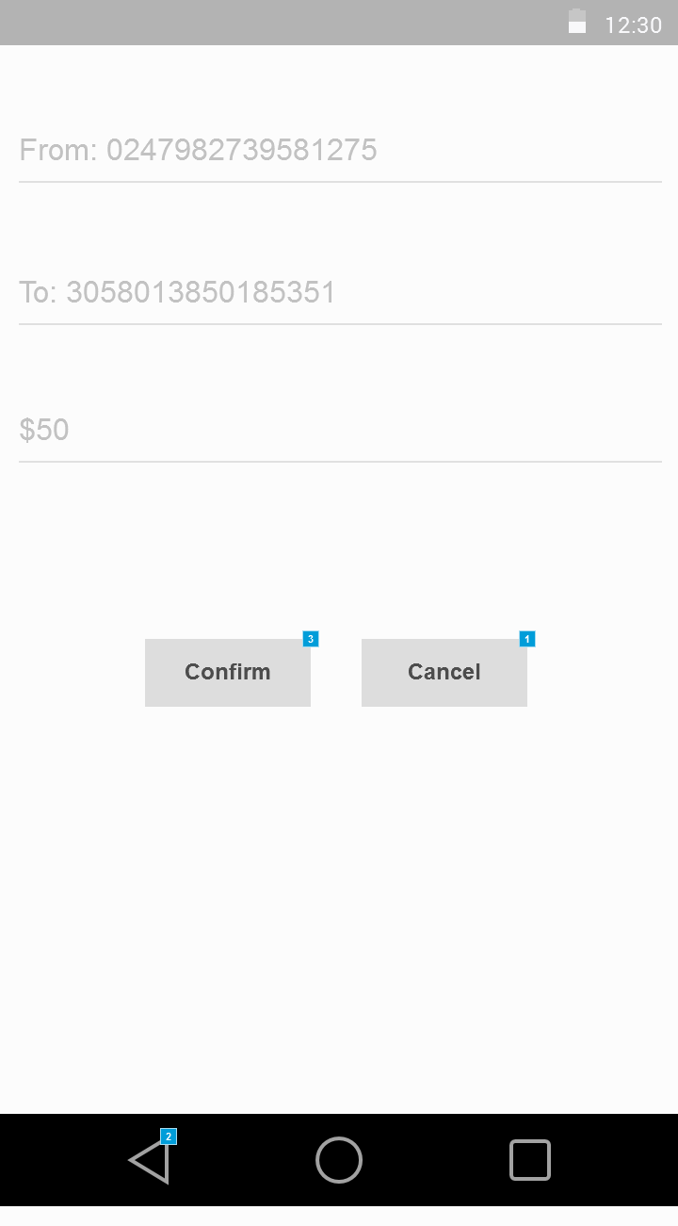

* + 1. Widget Table

|  |  |
| --- | --- |
| Footnote | Interactions |
| 1 | OnClick:  Case 1:  Open Transfer in Current Window |
| 2 | OnClick:  Case 1:  Open Transfer in Current Window |
| 3 | OnClick:  Case 1:  Open Account Info in Current Window |